**JHS Command Center portal.**

User-interface, Experience and Behavior of Heuristic Evaluation.

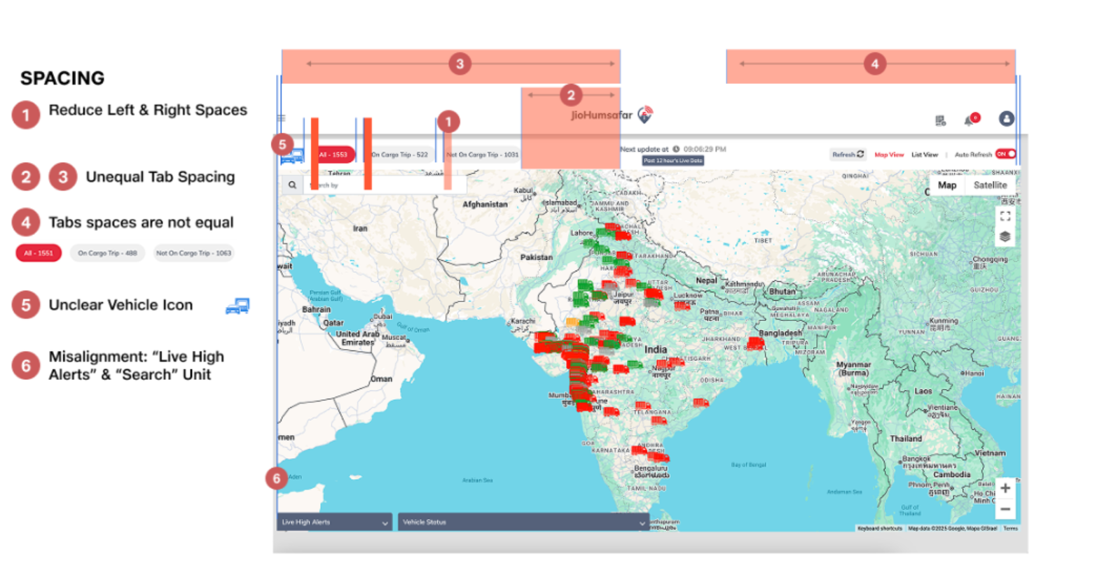

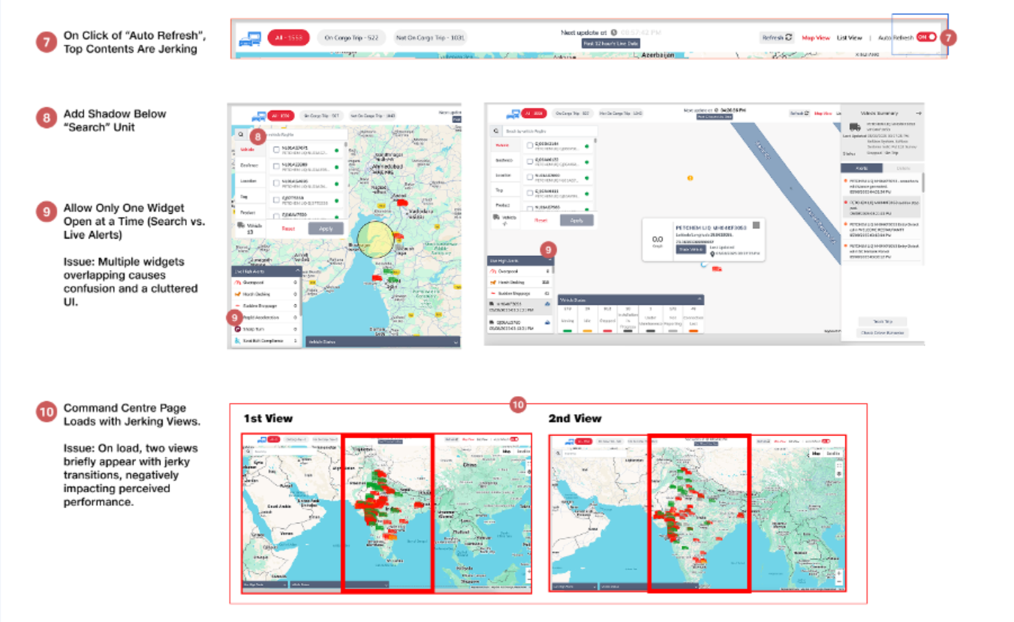

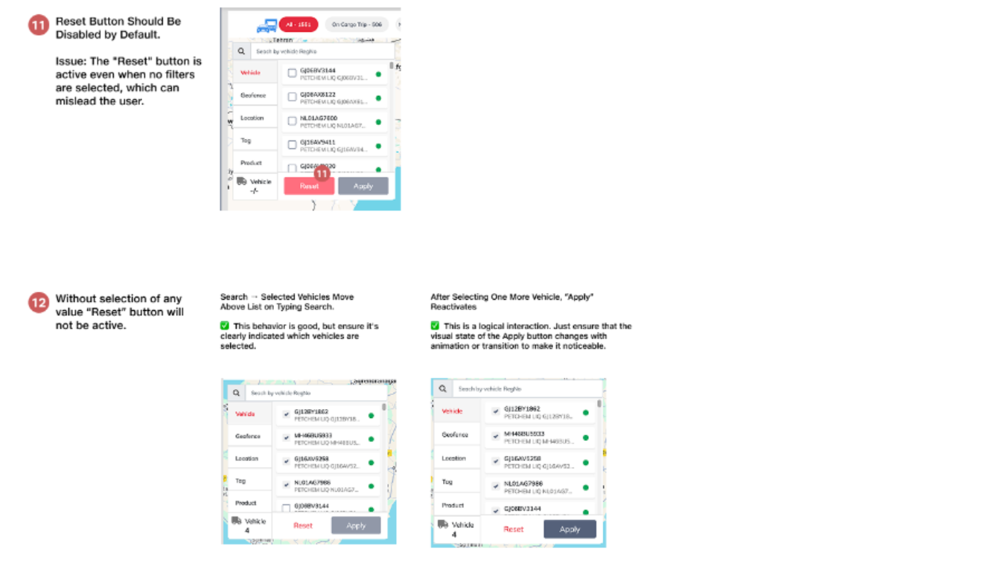

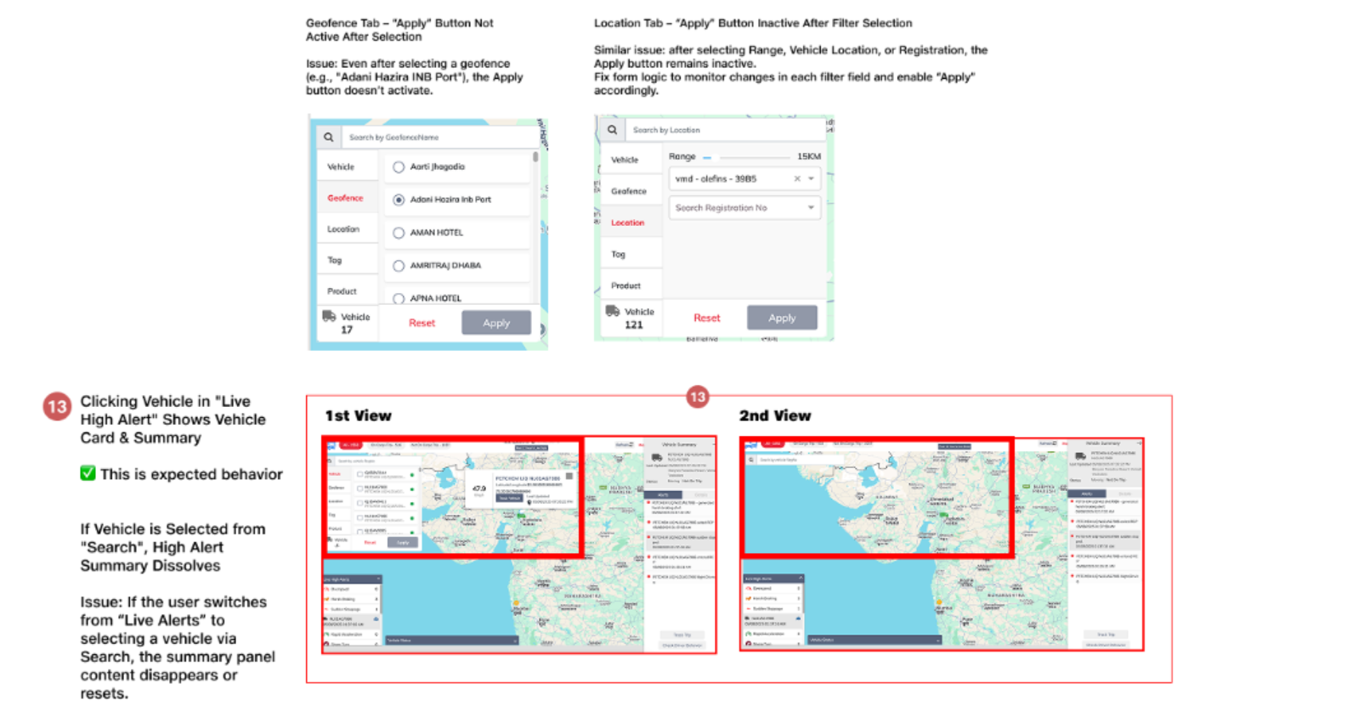

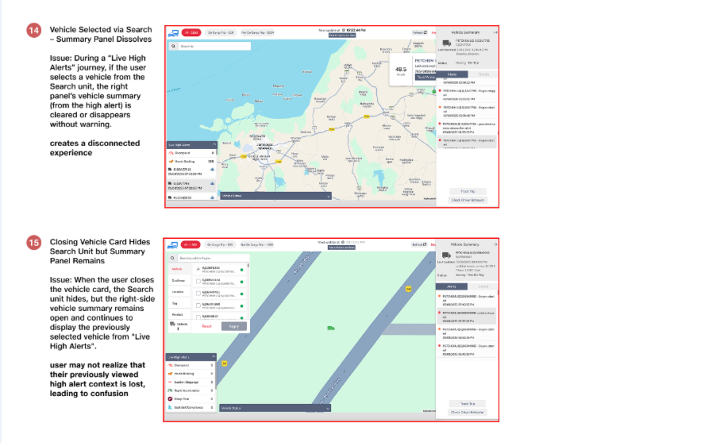

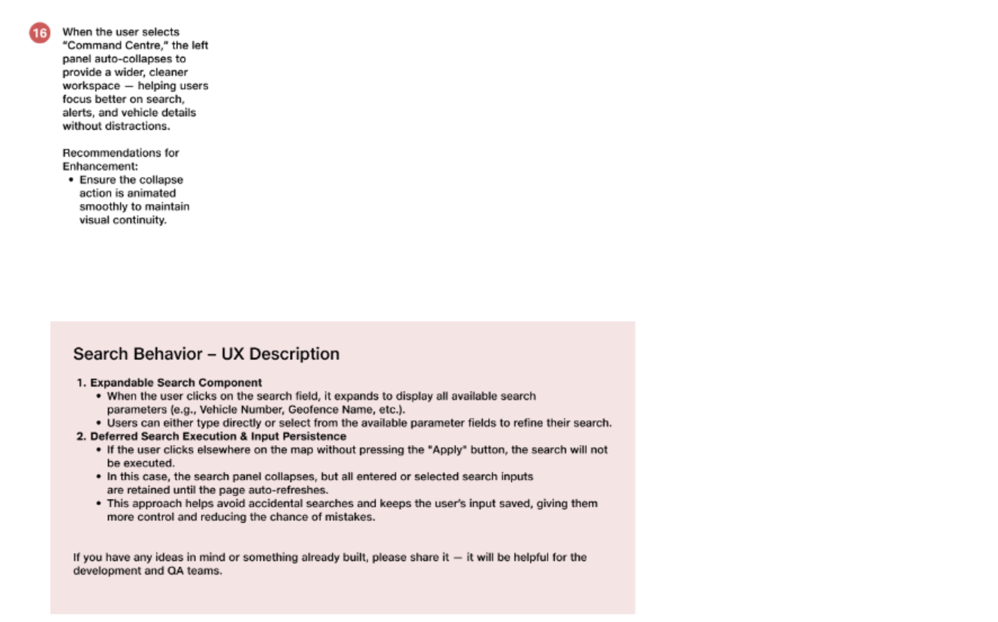

**Highlighted green already commented by JHS team. Reverted from Nikhil.**

1. Analytics is missing which was there in earlier page – This was discussed with VIvek and it was not working/useful – so it was decided to be hidden – post product discussion we can change and enable
2. Alert Icon is very small and almost not visible. Also it is not clickable. Should have detaisl same as Playback on click and open Alert and Vehicle summary bar on right if collapsed HB I checked. You may use Location Icon size and color as example. It is way better. –WAE - Done as per design – prefer to be flagged at figma level

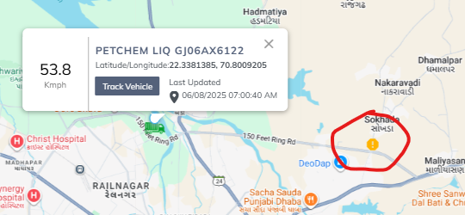

1. Time to load per alert is 5s+ . I check HB alert – noted and team already checking
2. Speed Graph does not have X-Axis marks. Does not give confidence it has 120 data points – x axis with time is looking very messy as it is a small space – that is why time is present on hover of the graph

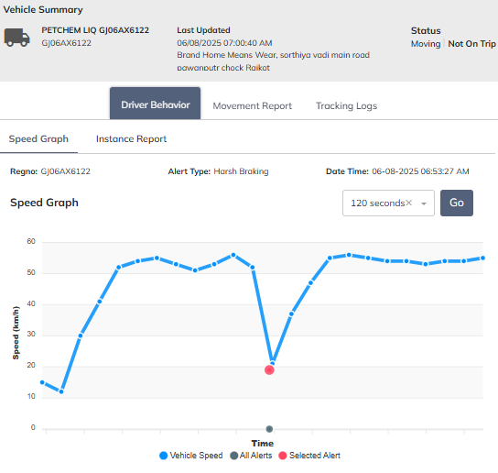

1. Marking is wrong – The marking will be a range of few seconds as some data will be not present at exact second/millisecond

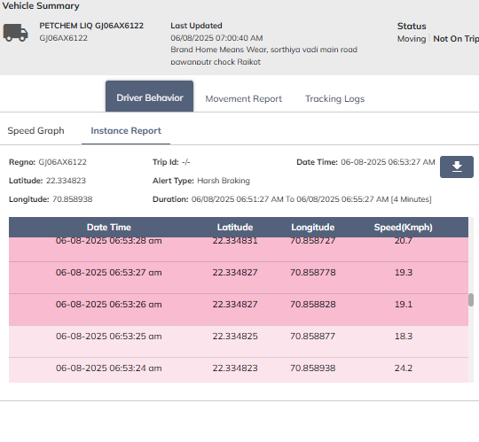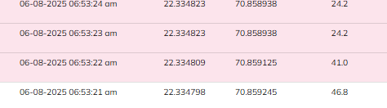

1. To be discussed: Should Auto refresh happen at background when Driver behaviour is being validated by user – user should disable auto refresh – also this is the reason we discussed if autorefresh is needed
2. Instance report in my opinion Date and Time should be in Ascending Order – small change – but prefer if this was highlighted during figma review
3. No marking of Alert in Movement Report, Tracking Logs – this again was a last min addition to the other 2 graphs as well , due to lack of time it was only enabled for few – not present in figma

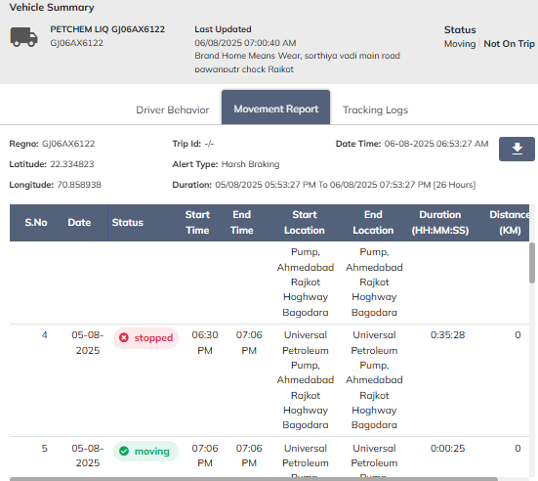

1. Movement Report , Vehicle History Report, Instance Report,  Download should have – Product, Trip ID, Ref Id, Transporter, Route Code if applicable, Origin and Destination- we can discuss and detail out

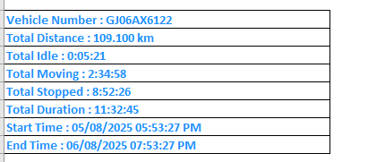

1. Track Trip is 2 clicks. It has to open Trip Summary page on single click. – small change – but prefer to have this at figma or preprod review time
2. If vehicle not on trip and Track Trip clicked, either it should show a message that vehicle is not on trip or button should be disabled with different color. – noted
3. I do not think Geofence and Geofence Name are working overlaying map. Was working earlier – didn’t understand this – we can discuss
4. Traffic either remove or give. Preference is to give. -
5. List View Address is not coming – this is noted , its coming but after few seconds
6. Columns to be added if Portabel tracker – needs discussion and details
7. If I use Search bar in List view then Search bar collapses when searching for Geofence. This is not similar to map view experience. – noted
8. Search Bar has applied filter msg coming as default even when bar is collapsed. It should be “Search”. “Global Search”. “Search Vehicle/Product/Location/Transporter” – we can discussneed more details

cid:image007.png@01DC06B5.DE81FBA0

1. Command centre page Vehicle type like bus/car not showing. Option is required to search By vehicle name / vehicle type. – WAD  - product team to take a call on this
2. we need option outside geofence -(global ) search option not showing current updated feature. Which is required to check how many vehicle are not bind with any of the geofence. – WAD - product team to take a call on this
3. Moving vehicle direction not visible.  Previously when we zoom at very high level (full Zoom In) vehicle is showing moving. – This will be available as part of next release
4. When we search using geofence or any other search option we will get redirect to that particular section but when page auto refresh by 5 min again full map view gets shown. Page should again redirect automatically on previous search. –WAD -  This behaviour has been highlighted to product team , To overcome this it was decided to have toggle for auto refresh .
5. Time showing AM and PM in driver behaviour graph is only showing A. and P for AM and PM. – This we will rectify

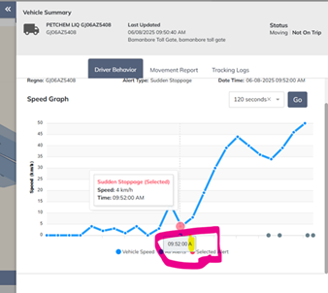

1. Any camera-based alert if we click on driver behaviour its redirect to Video request page where sometime vehicle number not populated automatically also Quota showing zero. Which is not even update. :- Blocker – This was fixed in prod – team will verify again

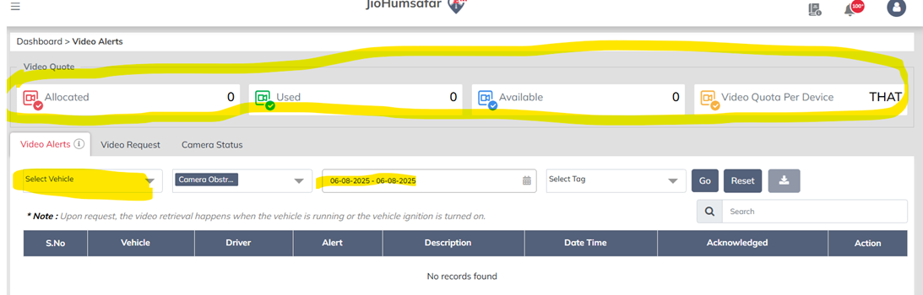

1. There is no option to press back from here to again on CC last open page. – WAD - This is a full fledged redirection as discussed with product team
2. Command Center page **count is not showing zero** sometimes its not update for longer duration. See below screenshot if I click all vehicle showing vehicles on MAP even when we click on moving according to that vehicle start populated on Map but no still shows zero.

Below example I wait for 2 min but count not reflect. – This could be a scenario where back button was used and some corner case – we will try to observe and reproduce

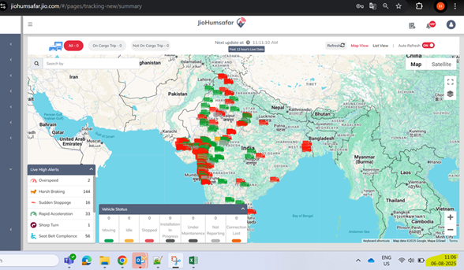  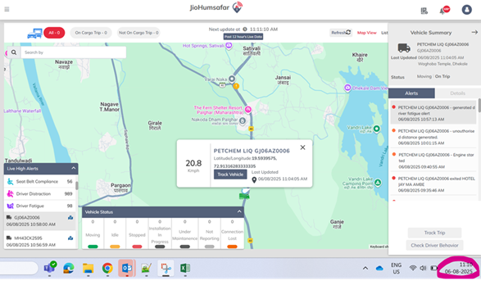

**Observations: -**

Primary feed back highlighted given here which is highlighted also I highlighted replied which are awaiting from JHS Team.

**Observation 1: Tag Filter and Map View Behavior During Navigation from Command Centre to Live Tracking and Back**

When a user navigates from the Command Centre to Live Tracking for a specific vehicle and then returns back:

1. The previously applied Tag filter (e.g., area/site-based) still appears selected in the filter bar. However, the map displays all vehicles, instead of only the filtered/tagged ones.

Yes, this is a known behaviour — when we go back to the Map page, it refreshes but the filter remains unchanged. [@Nikhil7 R](mailto:Nikhil7.R@ril.com) we need the page to refresh according to the previously selected filter.

1. The “Reset Filter” option does not work in this state. The user has to manually re-select the tag to reapply the correct filter.

[@Nikhil7 R](mailto:Nikhil7.R@ril.com) even though condition one will full fill “Reset Filter” Option should work.

1. Additionally, if the user was in Satellite View before switching to Live Tracking, on returning to Command Centre, the map switches back to Map View instead of retaining the previously selected Satellite View.

[@Nikhil7 R](mailto:Nikhil7.R@ril.com) Same as point no 1.

1. The toggled layers like Geofence, Geofence Name and Traffic remain selected in the UI, but they are not actually displayed on the map.

[@Sabirhushen Hingora](mailto:sabirhushen.ha@assettl.com) if point no 1 and 2 resolved this could get resolved.

[@Nikhil7 R](mailto:Nikhil7.R@ril.com) all are above point related to page switch. Filter not remain same. Previous page whatever we selected in filter or map view (like geofence, geofence name etc..) all gets refresh and not return back to Previous stage.

All above 4 points are taken, @ [@Nikhil7 R](mailto:Nikhil7.R@ril.com) please review these points and share feedback.

This causes confusion for users who rely on consistent filtered views, especially during surveillance or operations focusing on a specific area/event. It disrupts the workflow and requires manual corrections.

**Observation 2:  Auto-Refresh Interval Clarification**

Currently, the Auto Refresh interval in the Command Centre map is set to 5 minutes.

However, the Security Team has requested that this interval be reduced to 30 seconds for near real-time monitoring of vehicle activity and status.

Please check and confirm:

1. What is the minimum possible auto-refresh interval that can be configured in the current system?

Minimum possible keep 5 min because at the same page we given a option to analysis the alert. If page gets continuously refresh by 30 sec. page will might not be useful for validation. And load gets increase on each API call.

[@Nikhil7 R](mailto:Nikhil7.R@ril.com) please suggest.

1. Is 30 seconds refresh technically feasible without impacting system performance?

•  **Increased network usage** – Frequent calls mean more bandwidth consumption, which could slow down other activity on web portal.

•  **Page rendering delays** – If the call blocks UI updates or uses heavy data, the page may lag or feel less responsive.

[@Nikhil7 R](mailto:Nikhil7.R@ril.com) please suggest.

[@Sabirhushen Hingora](mailto:sabirhushen.ha@assettl.com) "Why doesn’t the Security team manually refresh the page? What benefit would they gain from a 30-second auto-refresh? In reality, at any given time on the map, we typically monitor only a few vehicles—usually one or two that are near each other. I’m trying to understand how they intend to view and monitor the map."

This enhancement is critical for the security team to maintain effective surveillance and timely response.

**Observation 3: Map View Reset on Refresh**

While using the Command Centre in Satellite View, it is observed that:

1. The selected map type (Satellite) remains consistent during auto or manual refresh. However, the map orientation, specifically the zoom level or pan position, changes upon refresh.

This behavior might affect visual monitoring during continuous surveillance or tracking and may require re-adjustment of the view each time the map refreshes.

[@Sabirhushen Hingora](mailto:sabirhushen.ha@assettl.com) Observation 3 and Observation 2 both are opposite to each other. Think about it if page refresh was happened every 30 second then visual monitoring continuously won’t be possible.

Whereas, [@Nikhil7 R](mailto:Nikhil7.R@ril.com) can we Implement functionality so that once the map zoom level reaches 60% or higher, the periodic map refresh is disabled, and live vehicle position updates are fetched and displayed in real time. This approach will allow us to provide a continuous surveillance/tracking view for the customer without interrupting the map context.

**Observation 4: Vehicle Grouping by Site**

Traffic team requested a feature to track vehicles group-wise, especially based on particular sites or areas, to make monitoring easier.

[@Sabirhushen Hingora](mailto:sabirhushen.ha@assettl.com) what exactly requirement here?

Group wise vehicle means type of vehicles?

Site and areas can define as a geofence which filter already there.

[@Vivek62 Singh](mailto:Vivek62.Singh@ril.com)  tomorrow we will connect and try to understand what is exactly asked here?

To meet this requirement:

1. We have utilized the existing Search by Tag Name functionality in the Command Centre.
2. Vehicles have been tagged area-wise (site-wise).

Now, users can simply use the tag filter to view and monitor vehicles from a specific tag.

**Observation 5: Missing Alert Data in Vehicle Info Popup (Right Click)**

When a user right-click on a vehicle in the Command Centre map, a popup opens showing the Vehicle Details, including sections like status, driver info and alerts.

However, the Alerts section always shows "No record found", even when the vehicle has recent alerts.

[@Nikhil7 R](mailto:Nikhil7.R@ril.com) and [@Sabirhushen Hingora](mailto:sabirhushen.ha@assettl.com) this is the bug please create a ticket.

Step to Reproduce the issue:-

1. Right Click on any vehicle on Map.
2. Left side vehicle details shown alert section always shows “No record found” for all vehicles.

